The Paramedic Hive Cognitive Mastery Series.



Table of Contents
1
Core Paramedic Cardiology Treatment Algorithms 2
1. Adult Cardiac Arrest Algorithm (Pulseless Patient) 2
Step 1 — Initial Actions 2
Step 2 — Identify Rhythm 2
Shockable Rhythm Treatment (VF / pVT) 2
Non-Shockable Rhythm Treatment (PEA / Asystole) 3
Hs and Ts (Reversible Causes) 3
2. Symptomatic Bradycardia Algorithm 3
Initial Treatment 3
Medication 3
If Atropine Fails 4
3. Tachycardia With Pulse Algorithm 4
Is the patient stable or unstable? 4
Unstable Tachycardia 4
Stable Tachycardia 4
Narrow complex 5
Wide complex 5
4. Acute Coronary Syndrome (ACS) Algorithm 5
Key early step: 5
Obtain a 12-lead ECG 5
Initial EMS Treatment 5
MONA-style approach 5
5. Post-ROSC Algorithm (After Return of Pulse) 5
Simplified EMS Cardiology Decision Tree 6
The Four Cardiology Algorithms Every Paramedic Must Know 7
Paramedic Cardiology Master Algorithm Sheet 7
1. Initial Cardiac Patient Assessment (Universal Algorithm) 7
2. Adult Cardiac Arrest Algorithm (Pulseless) 8
Immediate Actions 8
Identify Rhythm 8
Shockable Rhythm Treatment 8
Non-Shockable Rhythm Treatment 9
Reversible Causes (Hs & Ts) 9
3. Symptomatic Bradycardia Algorithm 9
First-Line Medication 10
If Atropine Fails 10
4. Tachycardia With Pulse Algorithm 10
Step 1: Determine Stability 10
Unstable Tachycardia 11
Stable Tachycardia 11
Narrow Complex Tachycardia 11
Wide Complex Tachycardia 11
5. Acute Coronary Syndrome Algorithm 12
Immediate Actions 12
Medications 12
Pain Control 12
6. Post-ROSC Care 13
7. Push-Dose Pressors for EMS 13
Push-Dose Epinephrine 13
Push-Dose Phenylephrine 14
14
8. Field Cardiogenic Shock Algorithm 14
Treatment 14
9. Ventricular Tachycardia Quick Guide 15
10. Field ECG Interpretation Priority 15
Critical Care Transport Cardiology Pearls 15
Quick EMS Cardiology Flow 16
Optional: “Paramedic Hive Cardiology Cognitive Check” 16
EMS Cardiology Mega-Algorithm 16
Step 1 — Identify the Patient State 16
Cardiology Master Decision Flow 17
Unstable Patient 17
Stable Patient 18
Field Cardiology Golden Rule 18
Paramedic ECG Recognition Guide 18
(20 Rhythms Every Medic Must Know) 18
Cardiac Arrest Rhythms 18
Ventricular Fibrillation 18
Pulseless Ventricular Tachycardia 20
Asystole 22
Unstable Tachycardia Rhythms 24
Ventricular Tachycardia 24
Supraventricular Tachycardia (SVT) 26
Bradycardia Rhythms 28
Sinus Bradycardia 28
Complete Heart Block 29
Acute Coronary Syndrome Rhythms 30
STEMI 30
3. When Electricity Beats Medication 32
Critical Care Cardiology Decision Guide 32
Use Electricity Immediately When 33
Ventricular fibrillation 33
Pulseless ventricular tachycardia 33
Unstable tachycardia 33
Symptomatic bradycardia not responding to atropine 33
Use Medication When? 33
The Cardiology Rule Most Experienced Medics Follow 34
Paramedic Cognitive Error Check 34
(A “Check My Ego” Cardiology Overlay) 34
High-Yield Cardiology Field Pearls 34
Biphasic Defibrillation Energy Settings (VF / Pulseless VT) 35
Initial Shock 35
Second Shock 35
Maximum Energy 35
Typical EMS Practice Pattern 35
Why Biphasic Energy Is Lower 36
Important Field Considerations 36
Quick Paramedic Pocket Guide 36
Transcutaneous Pacing Settings for Symptomatic Bradycardia 37
Step 1 — Set the Pacing Rate 37
Step 2 — Set the Output Current 37
Step 3 — Increase Current Until Capture 37
Signs of Electrical Capture 38
Confirm Mechanical Capture 38
Sedation Consideration 38
Symptomatic Bradycardia Algorithm (EMS Quick Flow) 39
Quick Paramedic Field Reference 39
Common EMS Mistakes with Pacing 39

Core Paramedic Cardiology Treatment Algorithms

1. Adult Cardiac Arrest Algorithm (Pulseless Patient)

Step 1 — Initial Actions
- Check responsiveness and pulse
- Start high-quality CPR
- Attach monitor/defibrillator
- Establish IV/IO access
- Secure airway and provide oxygen

Step 2 — Identify Rhythm
Shockable rhythms
- Ventricular fibrillation (VF)
- Pulseless ventricular tachycardia (VT)
Non-shockable rhythms
- Pulseless electrical activity (PEA)
- Asystole
The cardiac arrest algorithm branches depending on rhythm type.

Shockable Rhythm Treatment (VF / pVT)
- Defibrillate
- Resume CPR for 2 minutes
- Epinephrine 1 mg IV/IO every 3–5 min
- Defibrillate again
- Amiodarone 300 mg IV push (second dose 150 mg)
- Continue CPR and rhythm checks
Epinephrine is the primary vasopressor used during cardiac arrest to improve coronary and cerebral perfusion.

Non-Shockable Rhythm Treatment (PEA / Asystole)
- CPR immediately
- Epinephrine 1 mg IV/IO every 3–5 min
- Identify reversible causes (Hs & Ts)
- Rhythm check every 2 minutes

Hs and Ts (Reversible Causes)
Hs
- Hypovolemia
- Hypoxia
- Hydrogen ion (acidosis)
- Hypo/hyperkalemia
- Hypothermia
Ts
- Tension pneumothorax
- Tamponade
- Toxins
- Thrombosis (MI)
- Thrombosis (PE)

2. Symptomatic Bradycardia Algorithm
Bradycardia typically <50 bpm with symptoms such as hypotension, altered mental status, or ischemia.

Initial Treatment
- Maintain airway and oxygen
- Cardiac monitor
- IV access

Medication
Atropine
- 1 mg IV
- Repeat every 3–5 min
- Maximum 3 mg

If Atropine Fails
- Transcutaneous pacing
- Dopamine infusion
5–20 mcg/kg/min
- Epinephrine infusion

3. Tachycardia With Pulse Algorithm
First question:

Is the patient stable or unstable?
Signs of instability include:
- Hypotension
- Altered mental status
- Shock
- Chest pain
- Acute heart failure

Unstable Tachycardia
Immediate synchronized cardioversion
Energy examples:
- SVT → 50–100 J
- Atrial fibrillation → 120–200 J
- VT → 100 J+

Stable Tachycardia
Determine QRS width

Narrow complex
- Vagal maneuvers
- Adenosine 6 mg IV push
- Second dose 12 mg

Wide complex
- Amiodarone 150 mg IV over 10 min
- Prepare for cardioversion

4. Acute Coronary Syndrome (ACS) Algorithm

Key early step:

Obtain a 12-lead ECG
This determines if the patient has a STEMI requiring rapid reperfusion.

Initial EMS Treatment

MONA-style approach
- Oxygen (if hypoxic)
- Aspirin 324 mg
- Nitroglycerin 0.4 mg SL
- IV access
- Cardiac monitoring
Transport to PCI-capable hospital if STEMI.

5. Post-ROSC Algorithm (After Return of Pulse)
Goals:
- Oxygen saturation 94–99%
- Maintain systolic BP >90 mmHg
- 12-lead ECG
- Treat underlying cause
- Consider targeted temperature management

Simplified EMS Cardiology Decision Tree
Patient unstable?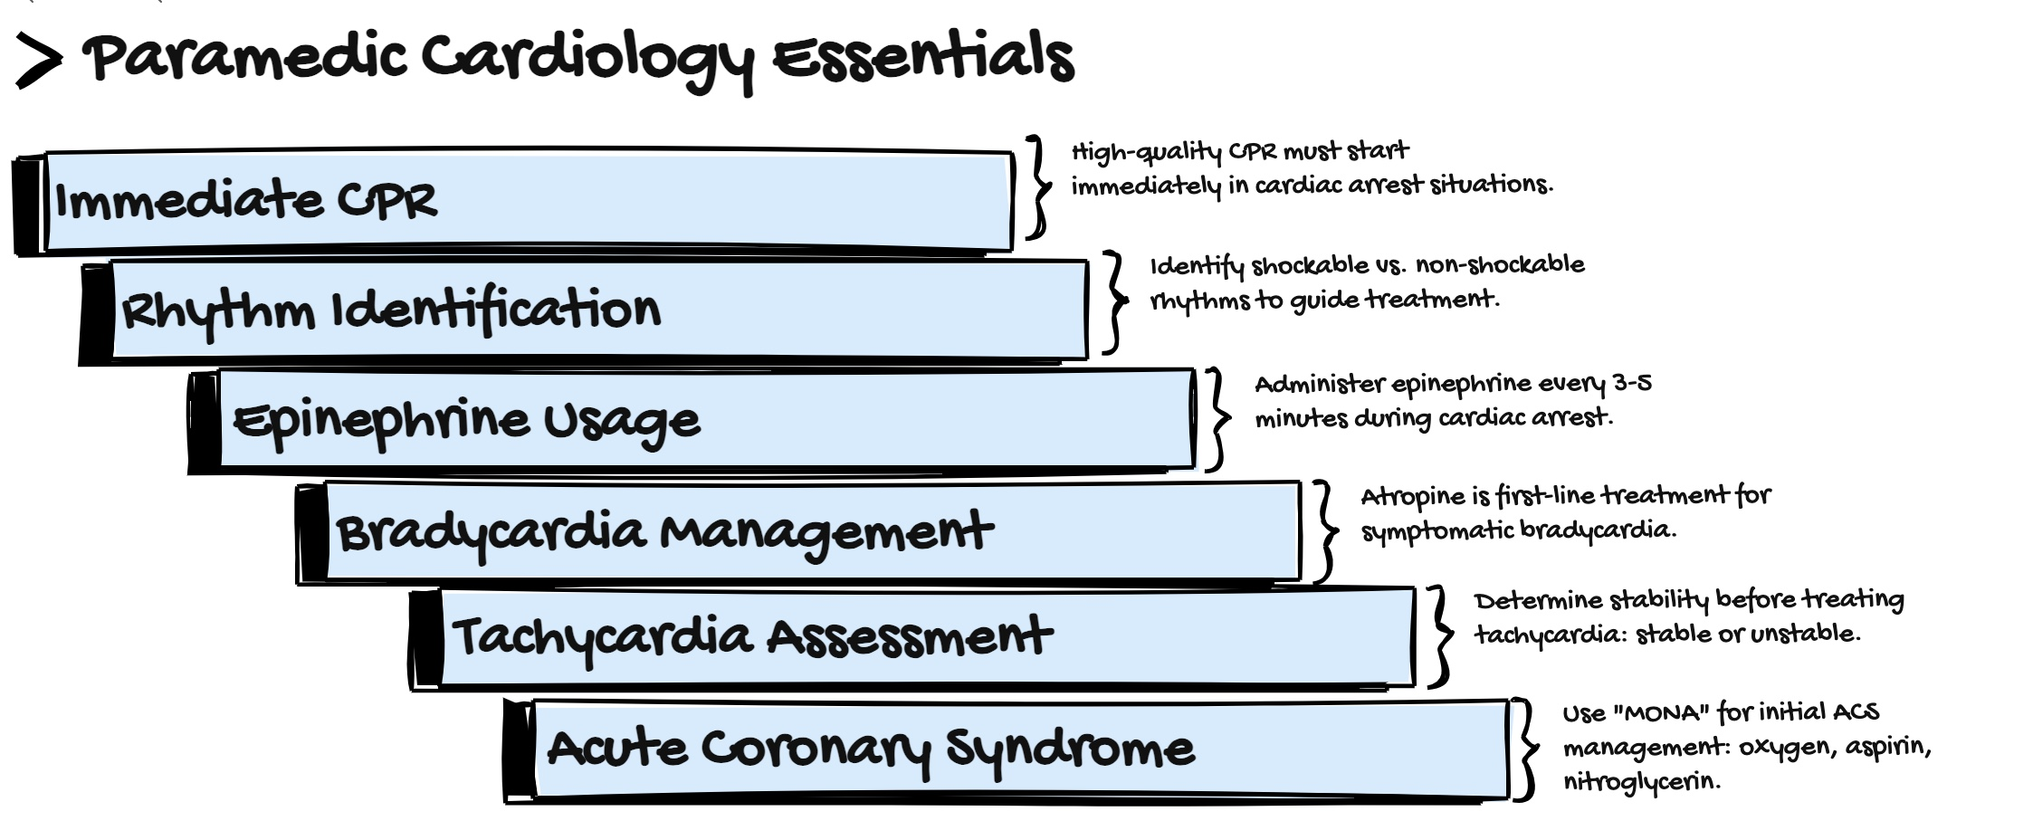
|
YES → Immediate intervention
(shock, pacing, cardioversion)
|
NO
|
Identify rhythm
|
├── Bradycardia → Atropine → pacing
├── Tachycardia → Adenosine / cardioversion
├── Cardiac arrest → CPR + defibrillation
└── Chest pain → ACS protocol

The Four Cardiology Algorithms Every Paramedic Must Know
- Cardiac Arrest
- Bradycardia
- Tachycardia
- Acute Coronary Syndrome
Mastering these allows paramedics to treat most field cardiac emergencies.

Paramedic Cardiology Master Algorithm Sheet
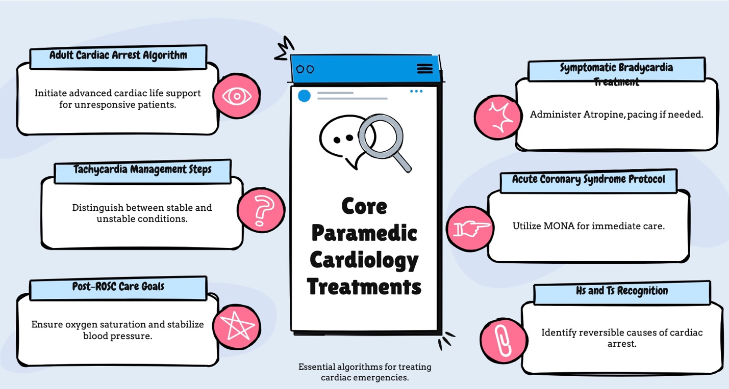

1. Initial Cardiac Patient Assessment (Universal Algorithm)
Primary survey
- Airway
- Breathing
- Circulation
- Cardiac monitor
- Pulse oximetry
- 12-lead ECG
- IV/IO access
Ask immediately
- Does the patient have a pulse?
- Is the patient stable or unstable?
This determines which cardiology algorithm to follow.

2. Adult Cardiac Arrest Algorithm (Pulseless)

Immediate Actions
- Start high-quality CPR
- Attach defibrillator
- Oxygen + airway
- IV/IO access

Identify Rhythm
Shockable:
- Ventricular fibrillation
- Pulseless ventricular tachycardia
Non-shockable:
- PEA
- Asystole

Shockable Rhythm Treatment
- Defibrillation
- CPR for 2 minutes
- Epinephrine 1 mg IV/IO every 3–5 minutes
- Defibrillation
- Amiodarone 300 mg IV push
- Second dose 150 mg
Alternative antiarrhythmic
Lidocaine 1–1.5 mg/kg IV

Non-Shockable Rhythm Treatment
- CPR immediately
- Epinephrine 1 mg IV/IO every 3–5 min
- Search for reversible causes

Reversible Causes (Hs & Ts)
Hs
- Hypoxia
- Hypovolemia
- Hydrogen ion (acidosis)
- Hypokalemia
- Hyperkalemia
- Hypothermia
Ts
- Tension pneumothorax
- Tamponade
- Toxins
- Thrombosis (MI)
- Thrombosis (PE)

3. Symptomatic Bradycardia Algorithm
Definition:
Heart rate <50 bpm with symptoms
Symptoms:
- Hypotension
- Altered mental status
- Chest pain
- Shock
- Acute heart failure

First-Line Medication
Atropine
Dose:
- 1 mg IV
- Repeat every 3–5 min
- Max 3 mg

If Atropine Fails
Transcutaneous pacing
OR
Infusions:
Dopamine infusion
5–20 mcg/kg/min
OR
Epinephrine infusion
2–10 mcg/min

4. Tachycardia With Pulse Algorithm

Step 1: Determine Stability
Signs of instability:
- Hypotension
- Altered mental status
- Shock
- Ischemic chest pain
- Acute heart failure

Unstable Tachycardia
Immediate synchronized cardioversion
Energy examples
SVT
50–100 J
Atrial fibrillation
120–200 J
Monomorphic VT
100 J+

Stable Tachycardia
Evaluate QRS width.

Narrow Complex Tachycardia
- Vagal maneuvers
- Adenosine 6 mg rapid IV push
- Second dose 12 mg

Wide Complex Tachycardia
Likely ventricular tachycardia.
Treatment:
Amiodarone
150 mg IV over 10 minutes
Repeat as needed.

5. Acute Coronary Syndrome Algorithm

Immediate Actions
- 12-lead ECG
- Cardiac monitor
- IV access
- Oxygen if hypoxic

Medications
Aspirin
324 mg chewable
Nitroglycerin
0.4 mg SL every 5 minutes
(max 3 doses)
Contraindications:
- Hypotension
- Right ventricular MI
- Recent PDE-5 inhibitor use

Pain Control
Fentanyl
25–50 mcg IV
Repeat as needed.

6. Post-ROSC Care
After return of spontaneous circulation:
Goals:
Oxygen saturation
94–99%
Systolic BP
90 mmHg
Obtain 12-lead ECG
Treat underlying cause.
Consider targeted temperature management.

7. Push-Dose Pressors for EMS
Used for peri-arrest hypotension.

Push-Dose Epinephrine
Mix:
1 mL cardiac epi (1:10,000)
into 9 mL saline
Result:
10 mcg/mL
Dose:
10–20 mcg every 1–5 minutes

Push-Dose Phenylephrine
Dose:
50–200 mcg IV
Best for tachycardic hypotension

8. Field Cardiogenic Shock Algorithm
Signs:
- Hypotension
- Pulmonary edema
- Cool clammy skin
- Altered mental status

Treatment
Oxygen
CPAP if pulmonary edema
IV access
Vasopressor support:
Norepinephrine infusion
0.05–0.5 mcg/kg/min
or
Dopamine
5–20 mcg/kg/min

9. Ventricular Tachycardia Quick Guide
Stable VT
Amiodarone
150 mg IV over 10 minutes

Unstable VT
Immediate synchronized cardioversion.

Pulseless VT
Defibrillation.

10. Field ECG Interpretation Priority
Paramedics should rapidly identify:
STEMI
Bradyarrhythmias
Ventricular tachycardia
Ventricular fibrillation
High-grade AV block

Critical Care Transport Cardiology Pearls
- Always obtain a 12-lead ECG early
- Treat the patient, not just the monitor
- Hypoxia causes arrhythmias
- Hypotension kills myocardium
- Many arrests are oxygenation failures

Quick EMS Cardiology Flow
Patient unstable?
YES → Immediate intervention
(cardioversion, pacing, defibrillation)
NO → Determine rhythm
Bradycardia → Atropine / pacing
Tachycardia → Adenosine / cardioversion
Cardiac arrest → CPR + defibrillation
Chest pain → ACS protocol

Optional: “Paramedic Hive Cardiology Cognitive Check”
Before giving a drug ask:
- Is the rhythm correct?
- Is the patient stable?
- Could hypoxia be the cause?
- Do I need electricity instead of medication?

EMS Cardiology Mega-Algorithm

This is the big-picture decision tree used in critical care transport and high-performance EMS systems.

Step 1 — Identify the Patient State
Ask three questions immediately:
- Does the patient have a pulse?
- Is the patient stable?
- What is the rhythm?

Cardiology Master Decision Flow
No pulse
→ Start CPR
→ Defibrillator attached
→ Rhythm check
Shockable rhythm
→ Defibrillate
→ Epinephrine
→ Amiodarone
Non-shockable rhythm
→ CPR
→ Epinephrine
→ Treat Hs & Ts

Pulse present
Check stability.

Unstable Patient
Signs:
- Hypotension
- Altered mental status
- Ischemic chest pain
- Acute heart failure
- Shock
Treatment:
Bradycardia
→ Pacing
Tachycardia
→ Synchronized cardioversion

Stable Patient
Identify rhythm.
Bradycardia
→ Atropine
Narrow tachycardia
→ Adenosine
Wide tachycardia
→ Amiodarone
Chest pain
→ ACS protocol

Field Cardiology Golden Rule
Electricity beats medication in unstable patients.

Paramedic ECG Recognition Guide

(20 Rhythms Every Medic Must Know)
These rhythms represent over 95% of field cardiology problems.

Cardiac Arrest Rhythms

Ventricular Fibrillation
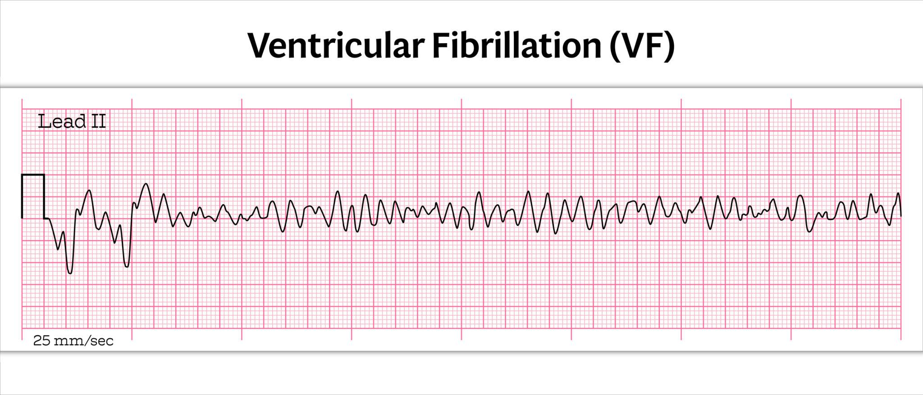
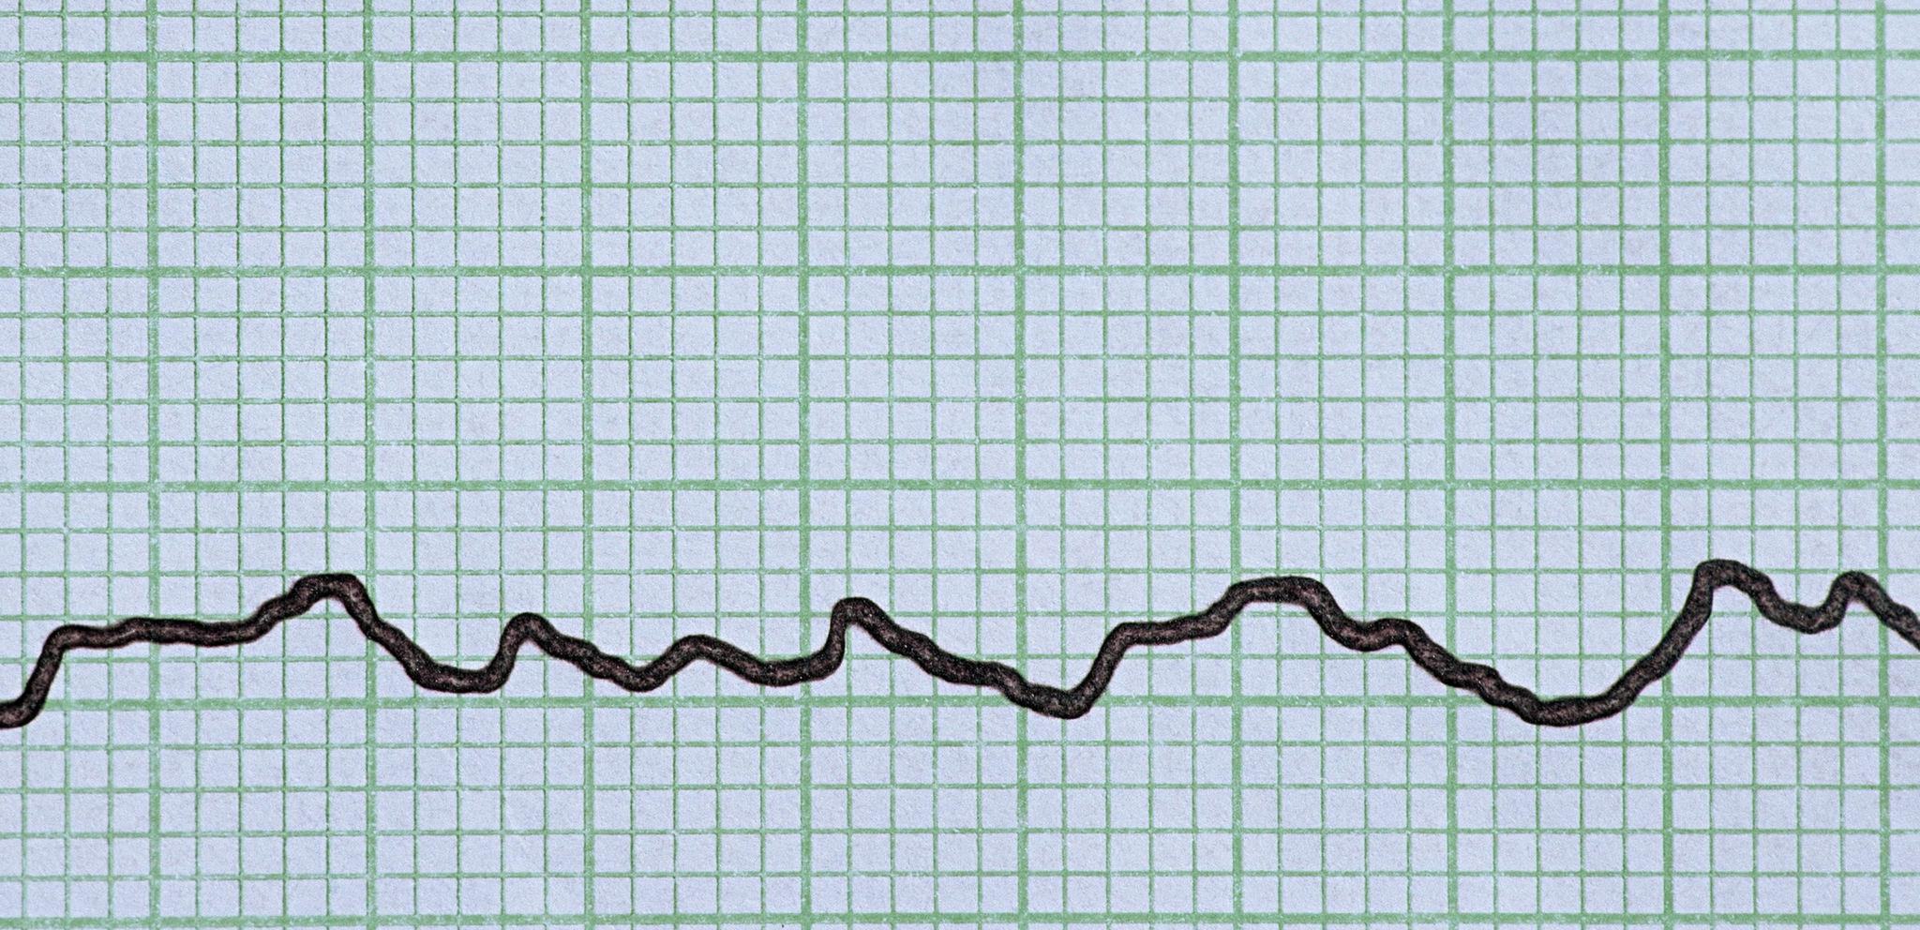
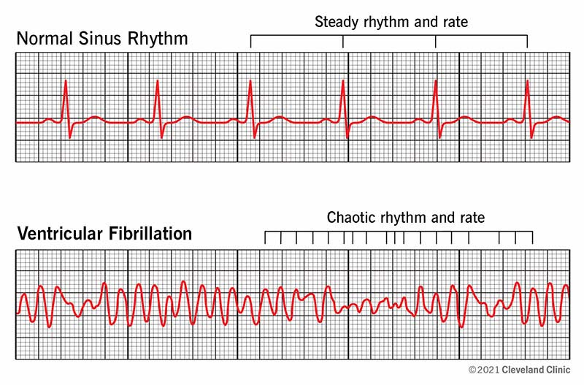
4
Characteristics
- Chaotic waveform
- No organized QRS
- No pulse
Treatment
- Immediate defibrillation

Pulseless Ventricular Tachycardia
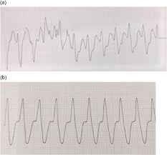
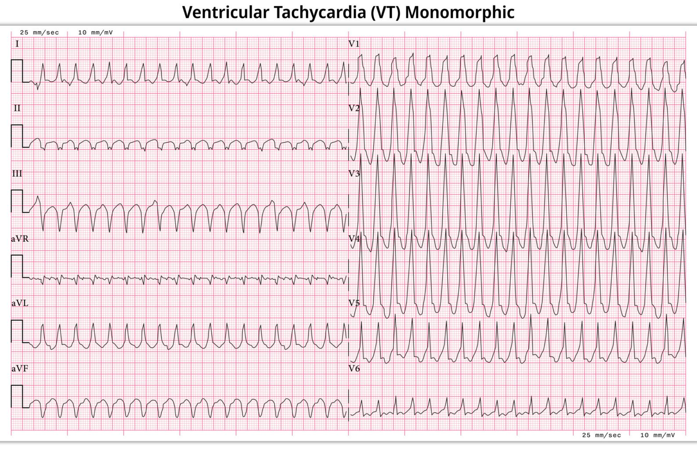
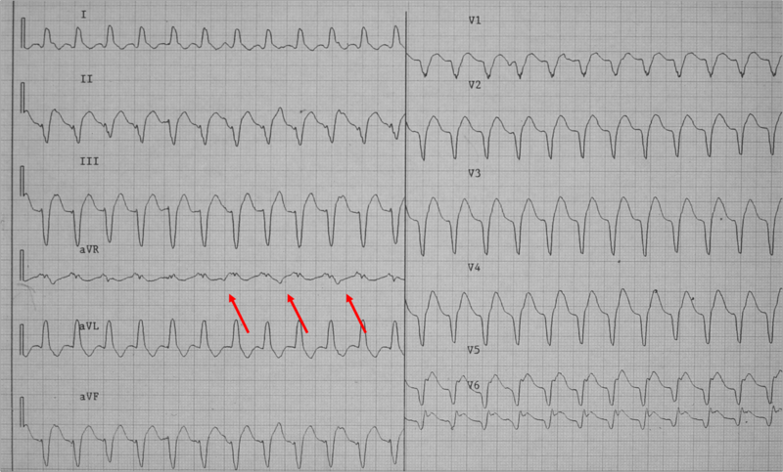
4
Characteristics
- Wide complex
- Fast rate
- No pulse
Treatment
- Defibrillation

Asystole
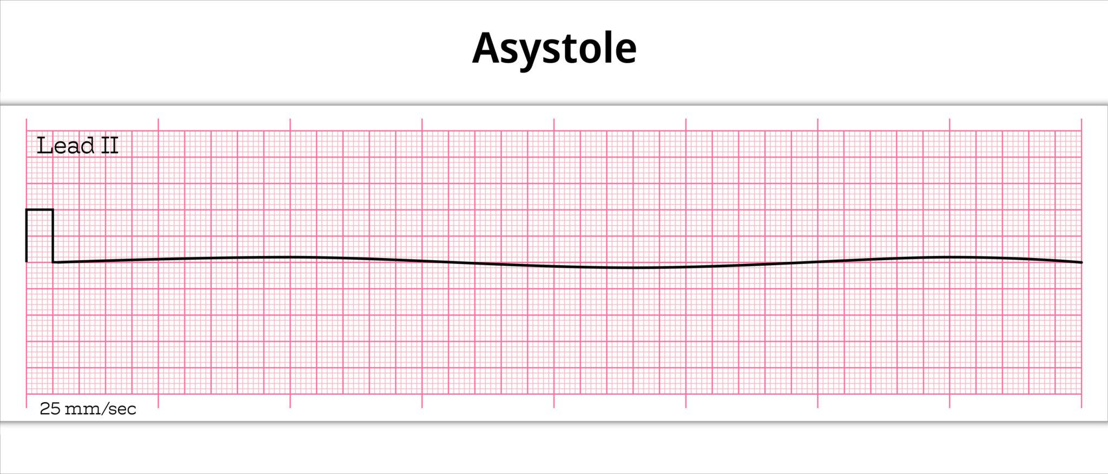
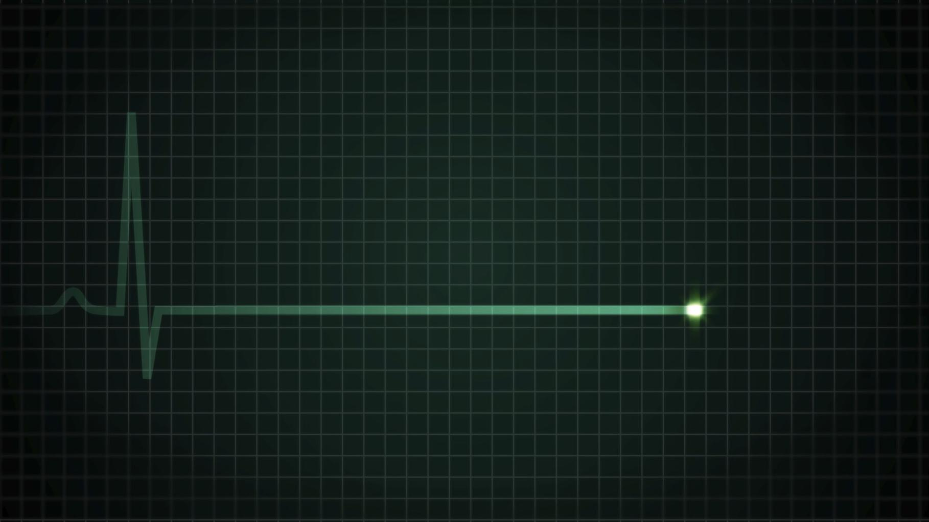
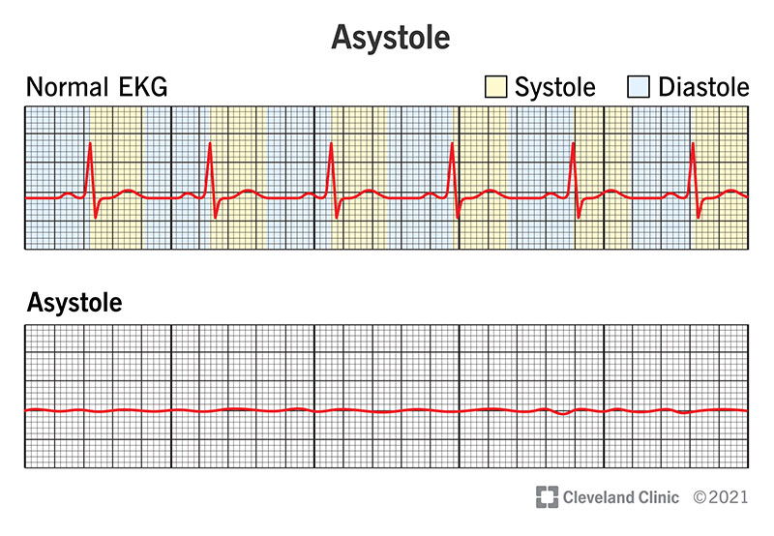
Characteristics
- Flat line
- No electrical activity
Treatment
- CPR
- Epinephrine

Unstable Tachycardia Rhythms

Ventricular Tachycardia

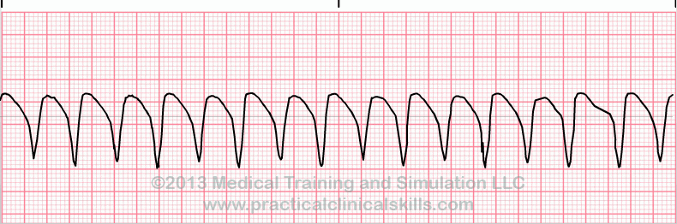
4
Characteristics
- Wide QRS
- Rate usually 150–250
- Often regular
Treatment
Stable
→ Amiodarone
Unstable
→ Cardioversion

Supraventricular Tachycardia (SVT)
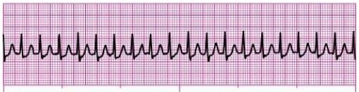
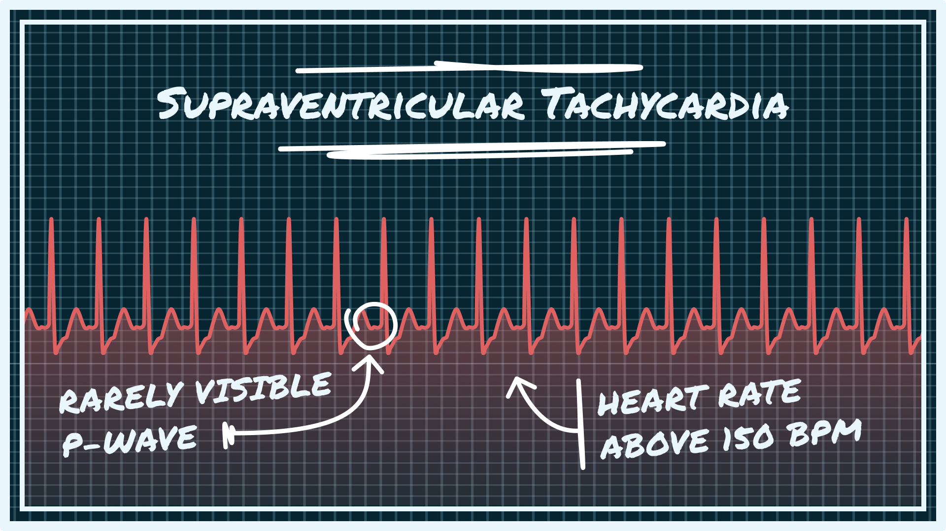
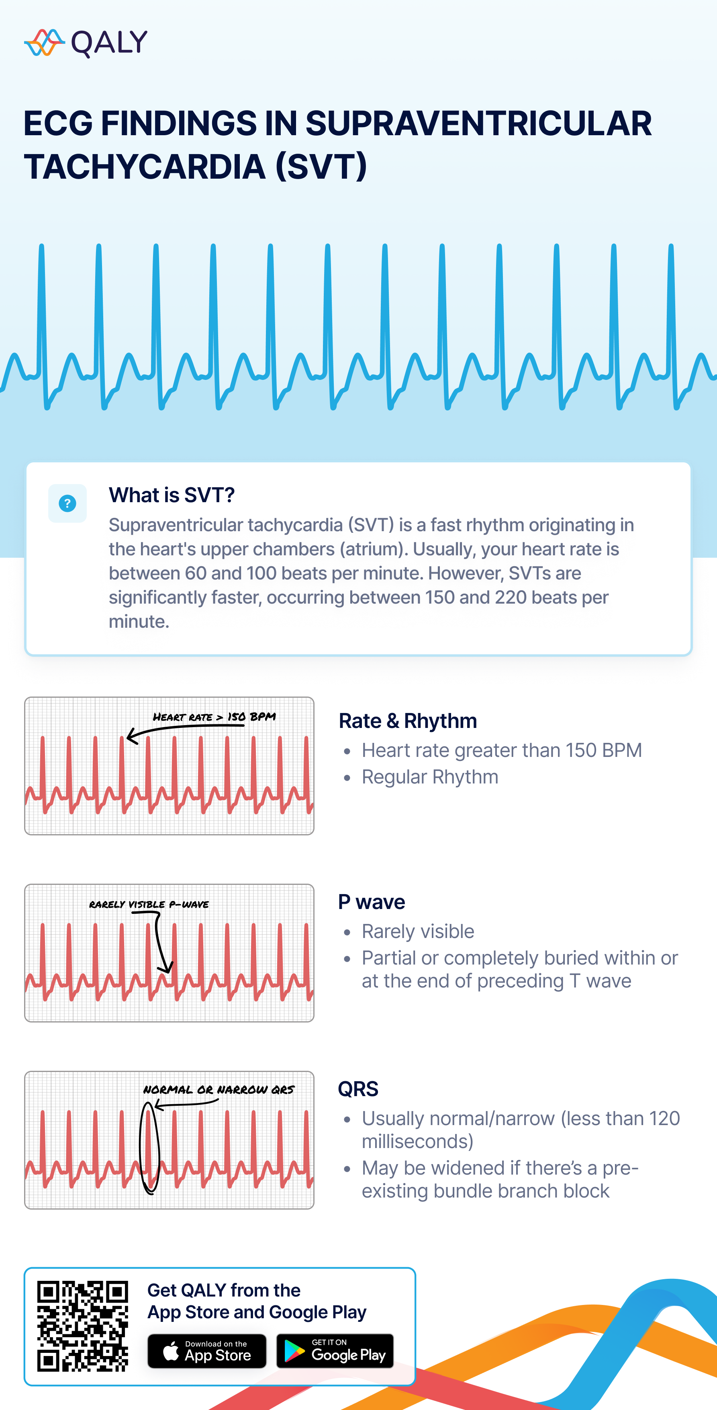
Characteristics
- Narrow complex
- Rate often >150
- P waves difficult to see
Treatment
- Vagal maneuvers
- Adenosine

Bradycardia Rhythms

Sinus Bradycardia
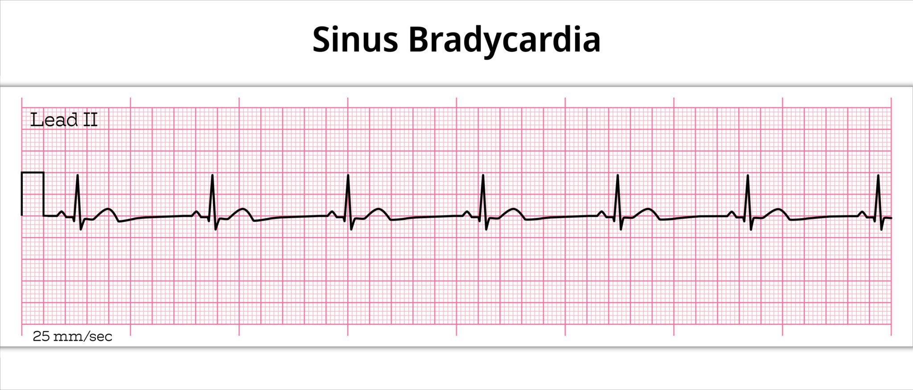
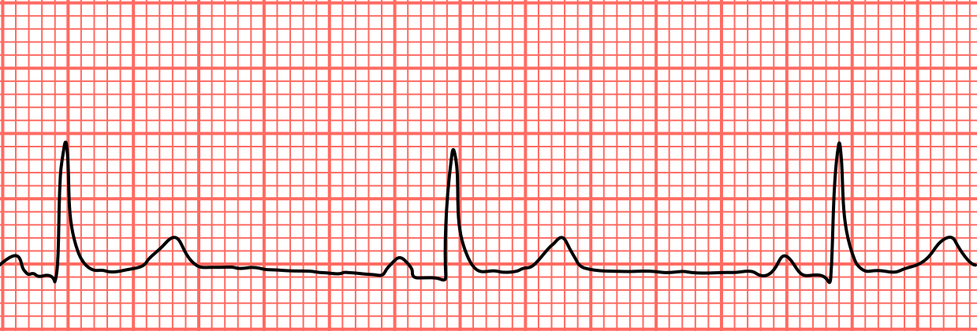
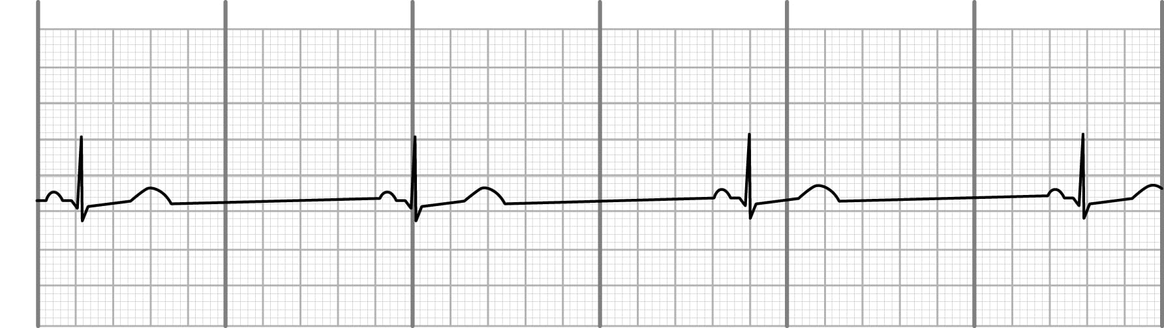
4
Characteristics
- Normal sinus rhythm
- Rate <60
Treatment
If symptomatic
→ Atropine
→ Pacing

Complete Heart Block
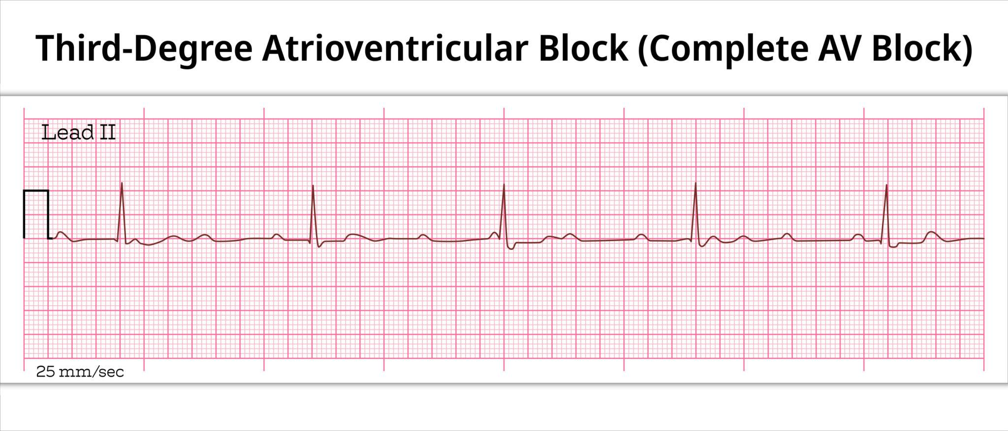
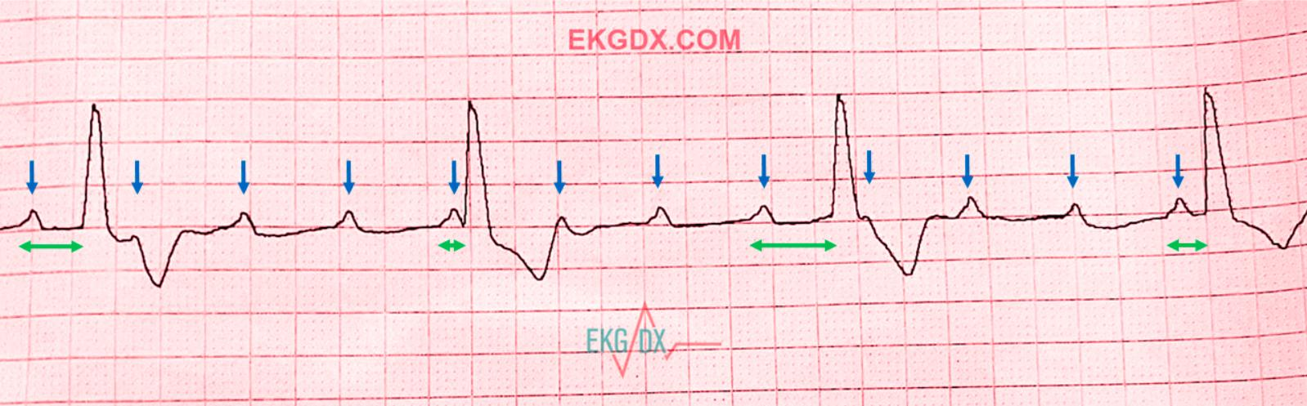
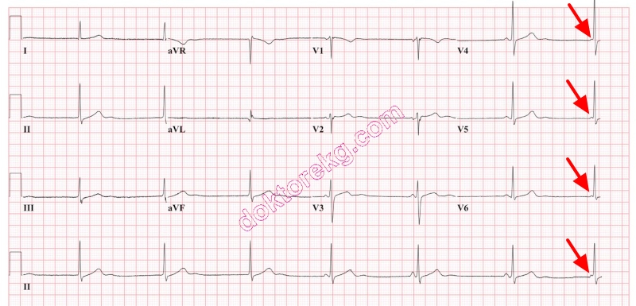
4
Characteristics
- P waves independent of QRS
- Severe bradycardia
Treatment
- Pacing

Acute Coronary Syndrome Rhythms

STEMI
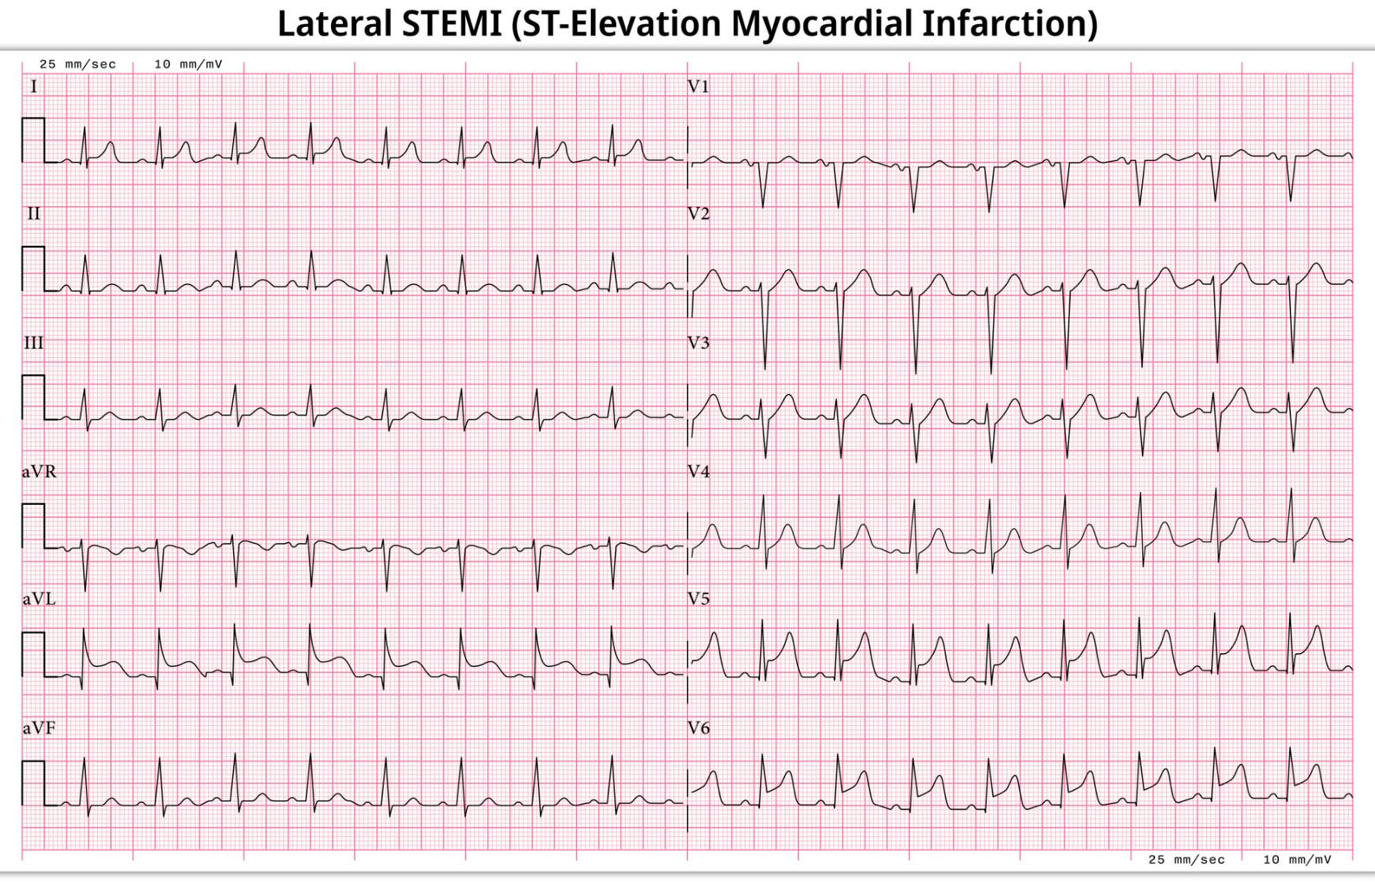
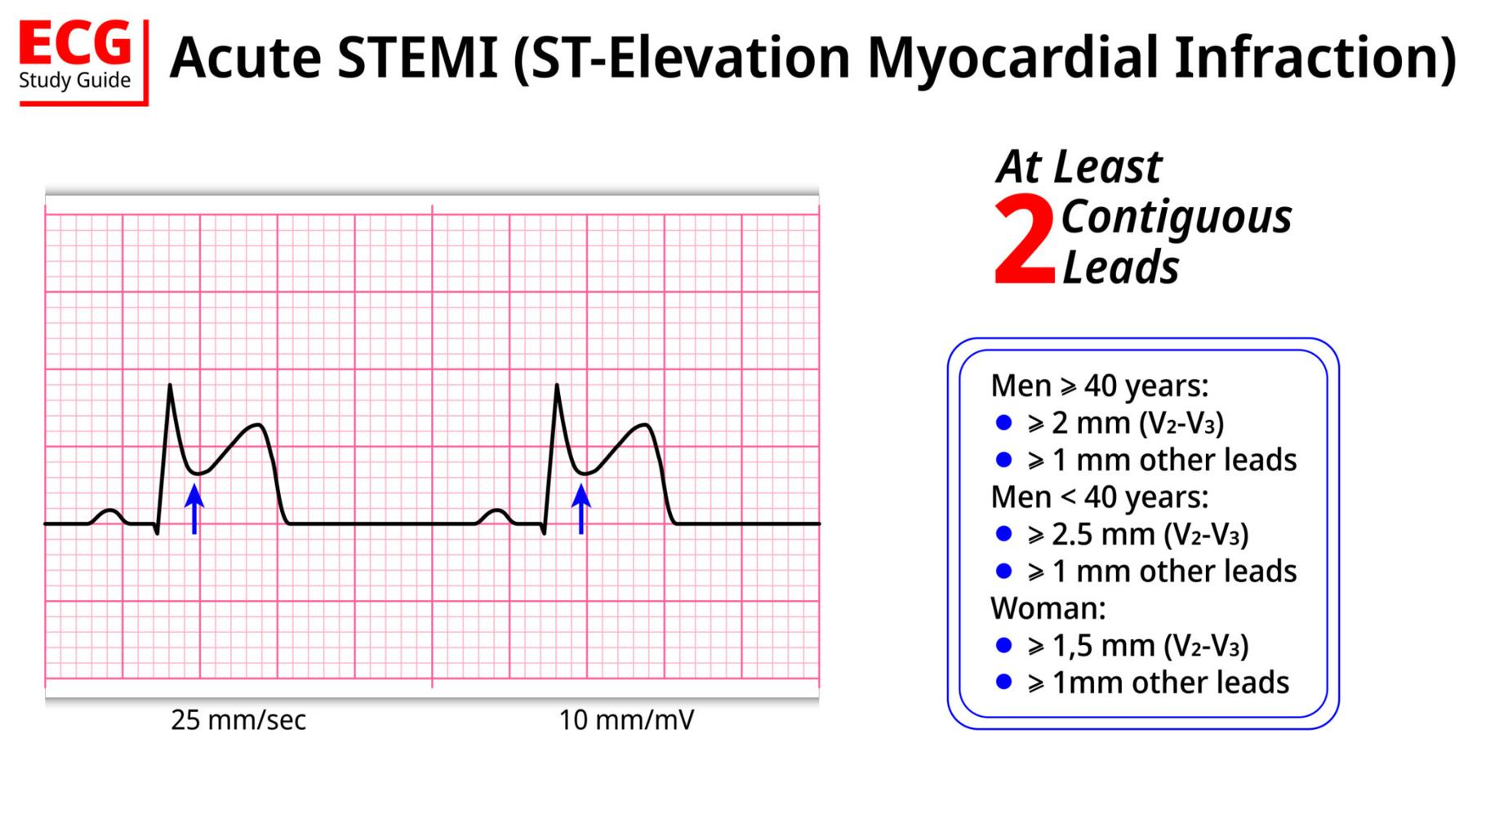
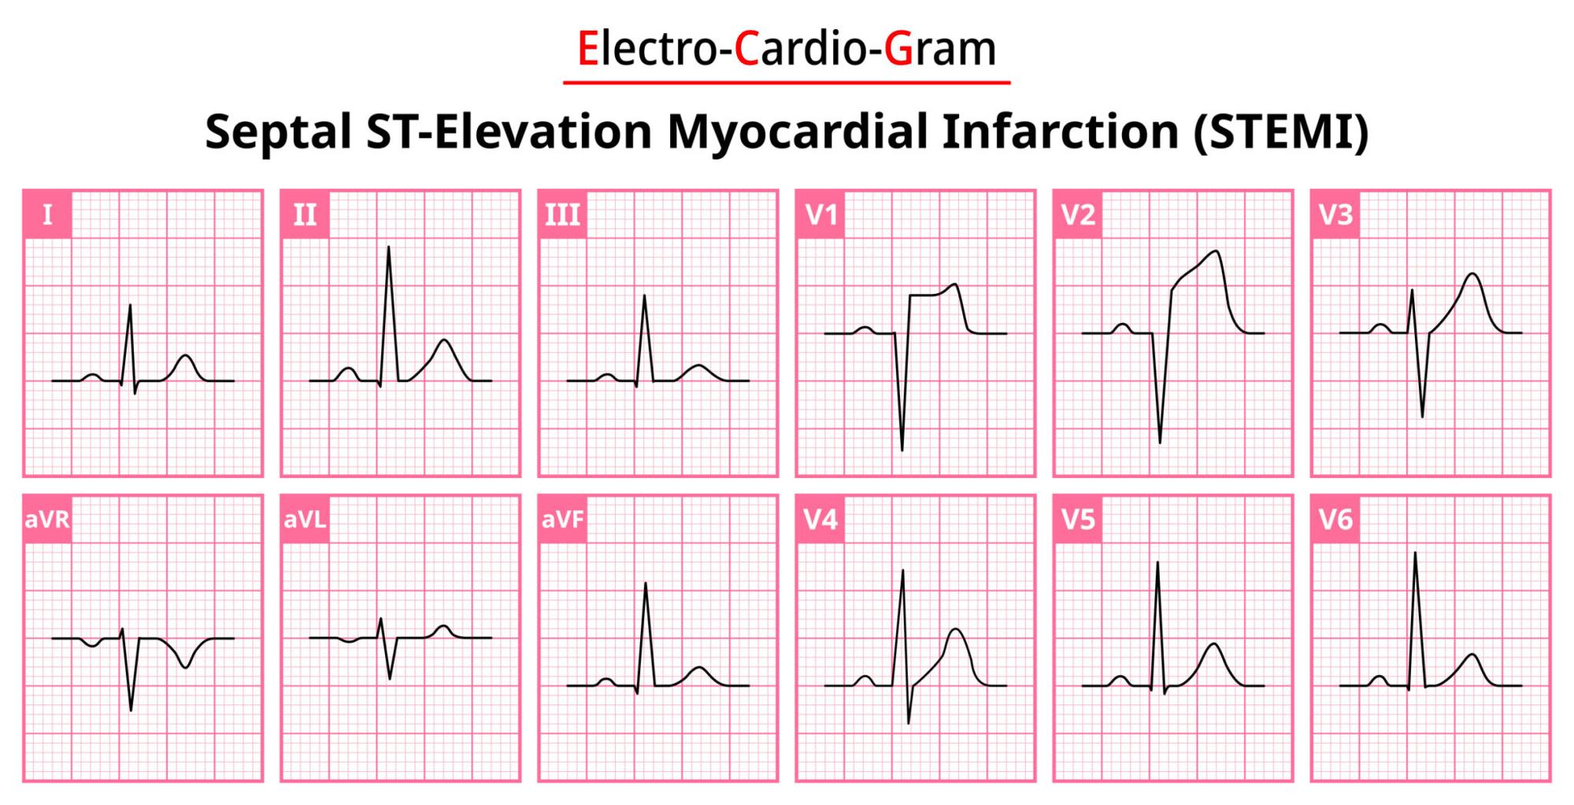
4
Characteristics
- ST elevation
- Reciprocal changes
Treatment
- Aspirin
- Nitroglycerin
- Rapid PCI transport

3. When Electricity Beats Medication

Critical Care Cardiology Decision Guide
One of the biggest mistakes in prehospital cardiology is delaying electricity while trying medications.

Use Electricity Immediately When

Ventricular fibrillation
Treatment
Defibrillation

Pulseless ventricular tachycardia
Treatment
Defibrillation

Unstable tachycardia
Treatment
Synchronized cardioversion

Symptomatic bradycardia not responding to atropine
Treatment
Transcutaneous pacing

Use Medication When?
Patient is stable.
Examples
SVT
→ Adenosine
Stable VT
→ Amiodarone
Symptomatic bradycardia
→ Atropine
Hypotension
→ Vasopressors

The Cardiology Rule Most Experienced Medics Follow
If the patient is unstable, electricity usually fixes the problem faster than drugs.

Paramedic Cognitive Error Check

(A “Check My Ego” Cardiology Overlay)
Before committing to treatment ask:
- Is the rhythm actually what I think it is?
- Is the patient unstable?
- Am I delaying electricity by reaching for medication?
- Could hypoxia be causing the arrhythmia?
- Do I have reversible causes?

High-Yield Cardiology Field Pearls
• Most cardiac arrests begin with hypoxia or ischemia
• Ventricular tachycardia is ventricular until proven otherwise
• Wide complex tachycardia → treat as VT
• Early 12-lead ECG saves myocardium
• Hypotension after ROSC is extremely dangerous

Biphasic Defibrillation Energy Settings (VF / Pulseless VT)

Initial Shock
120–200 joules
- If the exact device recommendation is known → use that setting
- If unknown → 200 J is acceptable for most biphasic monitors

Second Shock
Same or higher energy
Example progression:
- 200 J
- 200–300 J
- 300–360 J

Maximum Energy
360 J biphasic
Some monitors cap lower depending on manufacturer.

Typical EMS Practice Pattern
Many EMS systems follow this simple approach:
1️⃣ First shock: 200 J
2️⃣ Second shock: 300 J
3️⃣ Third shock: 360 J
This escalating strategy improves defibrillation success.

Why Biphasic Energy Is Lower
Biphasic defibrillators deliver current in two directions, which:
- improves myocardial depolarization
- increases success rates
- requires less energy than monophasic shocks

Important Field Considerations
Immediately after shock:
- Resume CPR immediately
- Do not check pulse
- Continue for 2 minutes
- Reassess rhythm after CPR cycle

Quick Paramedic Pocket Guide
Rhythm | Action | Energy
VF | Defibrillate | 120–200 J
Pulseless VT | Defibrillate | 120–200 J
Unstable VT (with pulse) | Synchronized cardioversion | 100 J
SVT unstable | Cardioversion | 50–100 J
Atrial fibrillation unstable | Cardioversion | 120–200 J

✅ If you'd like, I can also show you something extremely useful many paramedics never learn formally:
A defibrillator waveform interpretation guide
(what VF, coarse VF, fine VF, and artifact actually look like on the monitor and when to shock).
Joule settings on a biphasic monitor for pacing symptomatic brady
For symptomatic bradycardia requiring transcutaneous pacing (TCP) on a biphasic monitor/defibrillator, the setting is not measured in joules like defibrillation.
Instead, pacing uses current measured in milliamps (mA).

Transcutaneous Pacing Settings for Symptomatic Bradycardia

Step 1 — Set the Pacing Rate
Typical starting rate:
60–80 beats per minute
Many EMS protocols begin at 70 bpm.

Step 2 — Set the Output Current
Start around:
50–70 mA
Then increase gradually until electrical capture occurs.

Step 3 — Increase Current Until Capture
Typical capture range:
70–120 mA
In some patients it may require:
up to 150–200 mA

Signs of Electrical Capture
On the monitor:
- Pacing spike
- Followed by wide QRS complex
Example pattern:
spike → QRS → spike → QRS

Confirm Mechanical Capture
Electrical capture is not enough.
You must confirm:
- Palpable pulse
- Rising blood pressure
- Improved mental status

Sedation Consideration
TCP is painful.
If patient is conscious:
Common EMS sedation options
Midazolam
- 2–5 mg IV
or
Fentanyl
- 25–50 mcg IV

Symptomatic Bradycardia Algorithm (EMS Quick Flow)
1️⃣ Assess airway / oxygen
2️⃣ Cardiac monitor + IV access
3️⃣ Atropine
- 1 mg IV
- Repeat every 3–5 min
- Max 3 mg
4️⃣ If atropine fails → Transcutaneous pacing
5️⃣ If pacing unavailable:
- Dopamine infusion
- Epinephrine infusion

Quick Paramedic Field Reference
Step | Action
Rate | 60–80 bpm
Start current | 50–70 mA
Increase until capture | usually 70–120 mA
Max | ~200 mA

Common EMS Mistakes with Pacing
- Not increasing mA high enough
- Assuming electrical capture = perfusion
- Forgetting sedation
- Not checking a pulse

